Year 10 Health Education - Program Overview and Information


Dear Guardians and Students,

Welcome to Health Education. Students undertaking this course once per week, in conjunction with Physical Education, which is twice per week. As a department, we wish to maintain a good level of communication between parents, students and teachers. Below is an overview of some key information about Health Education at Willetton Senior High School.

In Health, all students are required to have access to a laptop and have the current (most up to date) FREE Adobe Reader software. Please follow the steps below to download.

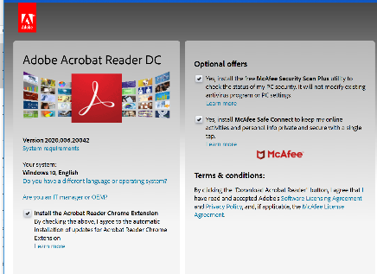
1. Google Adobe Acrobat Reader DC and then Download it onto your device (the e-book doesn’t always work on some tablets- PC’s/Macs are preferable). You may use the following link to assist you: https://acrobat.adobe.com/au/en/acrobat/pdf-reader.html
2. Make sure you install the Adobe Acrobat Reader DC – especially if you have a Mac

3. If you have a version older than Adobe 7 – please update

Each term, Students will be required to save and download their next topic’s Ebook. All Ebooks must be opened and saved with Adobe Acrobat Reader DC. A hard copy may be made available for students in special circumstances.

Assessment and Reporting for this subject is separate from Physical Education. We encourage all students and parents to use CONNECT pages to stay informed with current information and programs. All HPE teachers will use this platform to post Resources, E-books and Assessments. Some staff may use this as a medium for students to submit their work. Students and parents can download the CONNECT app to their devices ensuring they do not miss any important notices or information.

The program for Year 10 in 2024
Term 1: Relationships and Contraception
Term 2: Sexual Health – including STI awareness
Term 3: Impacts on Health – including the dimensions of health
Term 4: Keys 4 Life

Due to the nature of the content, the HPE department are aware that some students may have special circumstances that prevent full participation in discussions and activities. Please contact the Health teacher directly if you would like to discuss the program, WA curriculum or have any other queries.

Additionally, in all lower school Health Education courses, students may have the opportunity to watch a variety of appropriate feature films, documentaries, slideshows and television programs.

Health teachers may wish to use these mediums to provide additional learning support whilst delivering the curriculum. Your child’s Health Teacher will make contact if any films are of M or M15+ classifications. Should you have any queries please do not hesitate to contact me at the school or our Head of Department, Wayne Baseden.

Yours faithfully

Health Teacher
Willetton Senior High School

